Write a Servlet to demonstrate the difference between HTTP GET and POST
methods by creating a form and handling requests accordingly.

AIM

To create a web application that demonstrates the difference between HTTP GET and POST methods using Servlets. The application consists of an Online Result Collector Portal where users can search student results using the GET method and securely submit student marks using the POST method. The Servlet processes both requests and displays the corresponding output on the browser.

ALGORITHM

1. Input:

The user enters student details in the Online Result Collector form.

2. Form Handling:

• Create an HTML page with two forms.

• One form uses GET method for searching student result.

• Another form uses POST method for submitting student mark.

3. Servlet Processing:

• Create a Servlet class MethodServlet.

• Override doGet() method to handle GET request.

• Override doPost() method to handle POST request.

4. Request Handling:

• In GET method, retrieve Register Number and display result search message.

• In POST method, retrieve Name, Register Number and Mark, and display submission message.

5. Deployment:

• Configure web.xml.

• Deploy the project in Apache Tomcat Server.

6. Output:

• GET method displays data visible in URL.

• POST method displays data securely hidden from URL.

SOURCE CODE

User Interface (index.html)

<html>
<head>
<title>Online Result Collector - GET POST Demo</title>

<style>
body{
font-family:Arial;
background: linear-gradient(135deg,#2563eb,#0f172a);
margin:0;
color:white;
}

.container{
width:450px;
margin:70px auto;
padding:30px;
background:#111827;
border-radius:15px;
box-shadow:0 0 20px rgba(0,0,0,0.5);
text-align:center;
}

h1{
color:#60a5fa;
}

form{
margin-top:20px;
padding:20px;
border:1px solid #374151;
border-radius:10px;
}

input{
width:90%;
padding:10px;
margin:10px 0;
border:none;
border-radius:6px;
}

button{
width:95%;
padding:12px;
border:none;
border-radius:25px;
background:#2563eb;
color:white;
font-weight:bold;
cursor:pointer;
transition:0.3s;
}

button:hover{
background:#3b82f6;
transform:scale(1.05);
}
</style>

</head>

<body>

<div class="container">

<h1>ONLINE RESULT COLLECTOR</h1>

<form action="MethodServlet" method="get">
<h3>GET Method - Search Student Result</h3>
<input type="text" name="regno" placeholder="Enter Register Number" required>
<button type="submit">View Result with GET</button>
</form>

<form action="MethodServlet" method="post">
<h3>POST Method - Submit Student Mark</h3>
<input type="text" name="name" placeholder="Enter Student Name" required>
<input type="text" name="regno" placeholder="Enter Register Number" required>
<input type="number" name="mark" placeholder="Enter Internal Mark" required>
<button type="submit">Submit Result with POST</button>
</form>

</div>

</body>
</html>

Controller Servlet (LoginServlet.java)

import java.io.*;

import javax.servlet.*;

import javax.servlet.http.*;

public class MethodServlet extends HttpServlet {

public void doGet(HttpServletRequest request, HttpServletResponse response)

throws ServletException, IOException {

response.setContentType("text/html");

PrintWriter out = response.getWriter();

String regno = request.getParameter("regno");

out.println("<html><body style='text-align:center;font-family:Arial;background:#1d4ed8;color:white;'>");

out.println("<h1>GET METHOD RESULT SEARCH</h1>");

out.println("<h2>Register Number Searched : "+regno+"</h2>");

out.println("<h3>Student Result Retrieved Successfully</h3>");

out.println("<h3>Data Visible in URL using GET Method</h3>");

out.println("</body></html>");

}

public void doPost(HttpServletRequest request, HttpServletResponse response)

throws ServletException, IOException {

response.setContentType("text/html");

PrintWriter out = response.getWriter();

String name = request.getParameter("name");

String regno = request.getParameter("regno");

String mark = request.getParameter("mark");

out.println("<html><body style='text-align:center;font-family:Arial;background:#166534;color:white;'>");

out.println("<h1>POST METHOD RESULT SUBMISSION</h1>");

out.println("<h2>Student Name : "+name+"</h2>");

out.println("<h2>Register Number : "+regno+"</h2>");

out.println("<h2>Internal Mark Submitted : "+mark+"</h2>");

out.println("<h3>Student Data Submitted Securely</h3>");

out.println("<h3>Parameters Hidden from URL using POST Method</h3>");

out.println("</body></html>");

}

}

Web.xml
<web-app>

<welcome-file-list>
<welcome-file>index.html</welcome-file>
</welcome-file-list>

<servlet>
<servlet-name>MethodServlet</servlet-name>
<servlet-class>MethodServlet</servlet-class>
</servlet>

<servlet-mapping>
<servlet-name>MethodServlet</servlet-name>
<url-pattern>/MethodServlet</url-pattern>
</servlet-mapping>

</web-app>

OUTPUT :

Get Method:

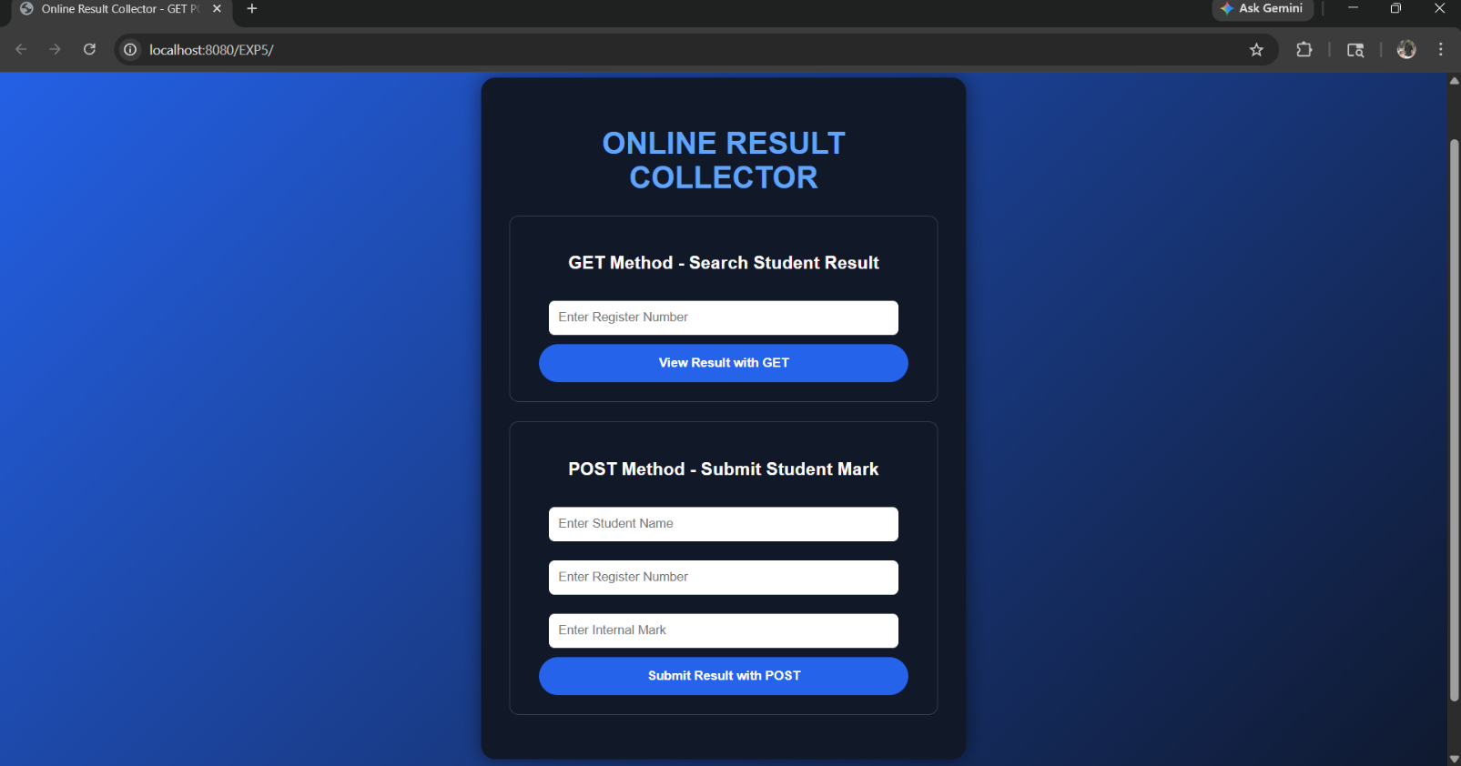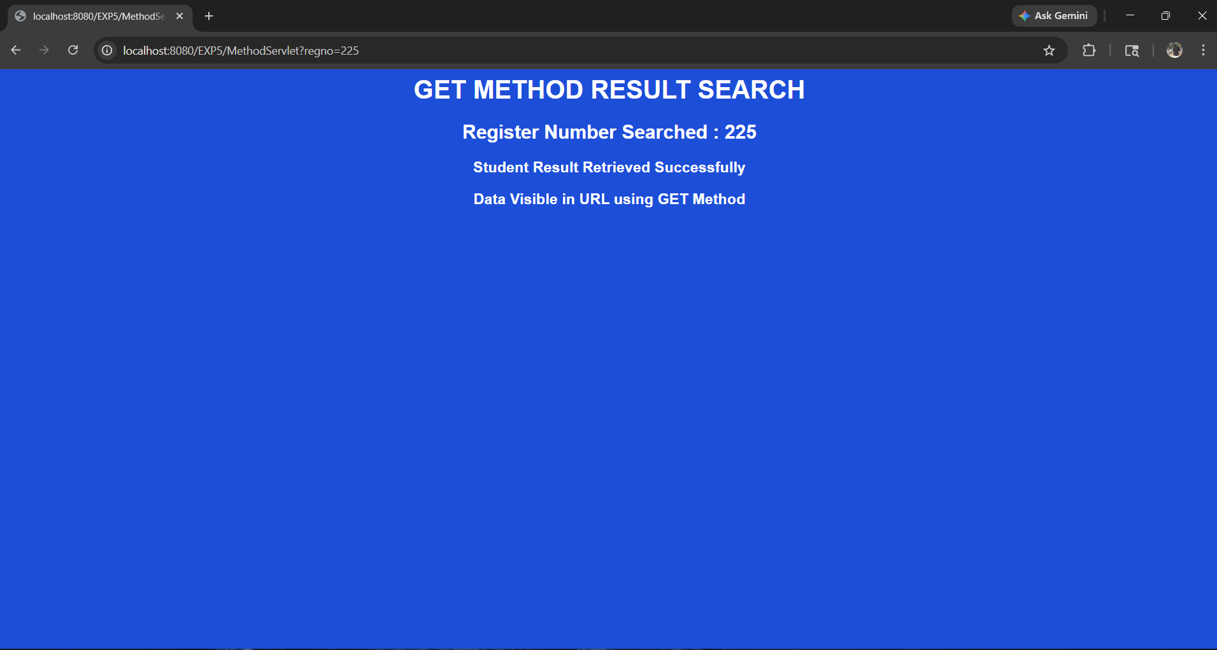

Post Method:

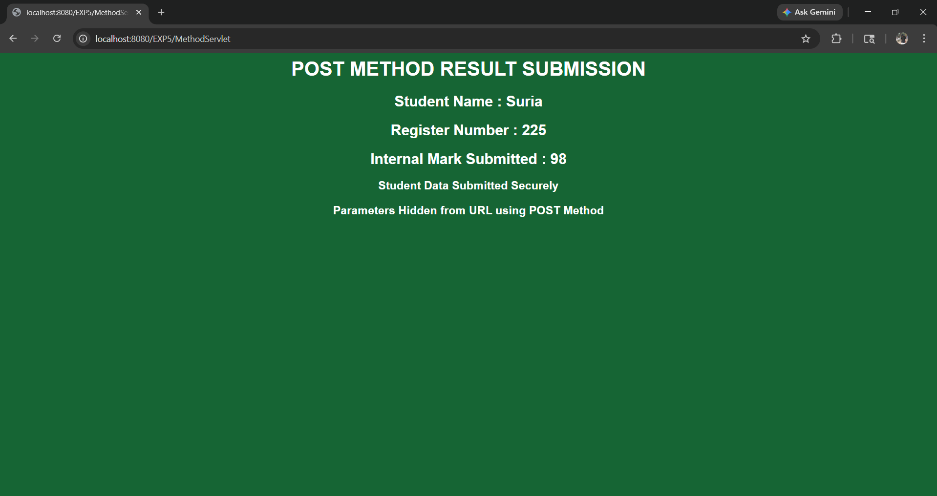

RESULT:
Thus a Servlet program was created successfully to demonstrate the difference between HTTP GET and POST methods using an Online Result Collector Portal.

